Towards long-wave infrared narrowband tunable FPIs
Gurpreet Singh Gill¹*, Michal Zawierta¹, Dhirendra Kumar Tripathi¹, Adrian Keating², Gino Putrino¹, Dilusha Silva¹, Lorenzo Faraone^{1,3} and Mariusz Martyniuk^{1,3}
¹ Department of Electrical, Electronic and Computer Engineering, ² Department of Mechanical Engineering, ³ARC Centre of Excellence on Transformative Meta-Optical Systems (TMOS); The University of Western Australia, Perth, WA – 6009, Australia
*gurpreet.gill@uwa.edu.au

Abstract: This work presents a surface micromachined long-wave infrared (LWIR) tunable Fabry–Pérot interferometer (FPI) incorporating Ge/BaF₂/Ge solid-material distributed Bragg’s reflectors (DBRs) for 8 – 10 µm optical wavelength range. Ge and BaF₂ thin film based static FPIs were integrated with a tuning mechanism to realise wavelength discrimination. This has been achieved using two different approaches to fabricate the tuneable cavity FPIs ($δ$- and $ε$-series), where the bottom high-index Ge layer of the top DBR was targeted to be either partially (in the case of $δ$-series FPIs) or fully (in the case of $ε$-series FPIs) replaced with a conformal Si layer in order to provide structural support to the top DBR. The fabricated FPIs exhibited peak transmission ranging from 20 – 25%, full width at half maxima (FWHM) ranging from 190 – 436 nm for the centre wavelength tuning from ~9.93 µm to ~7.98 µm. This work represents a reliable and reproducible fabrication process for tunable cavity LWIR FPIs.
Keywords: Fabry–Pérot interferometer, distributed Bragg’s reflectors, thin films, surface micromaching, long-wave infrared.
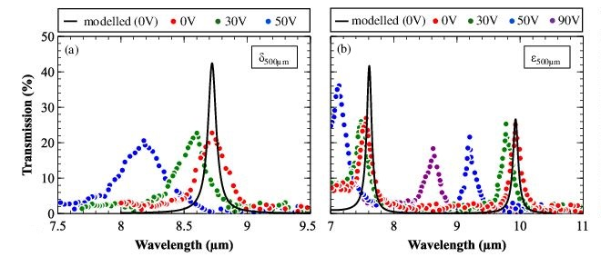
Transmission tuning spectra of tuneable cavity FPIs (δ- and ε-series). The transmission response is plotted linearly as percentage for FPIs that are 500um in latheral dimension for (a) $δ$ and (b) $ε$-series. The data points represent the measured FPIs transmission spectra at different DC voltages, whereas, the solid lines represent the modelled FPIs performance for an unactuated FP cavity.

